ASSIGNMENT – 3 (DA with TABLEAU)

**EMAIL:** [**poojithakavuri02@gmail.com**](mailto:poojithakavuri02@gmail.com)

**PHNO: 9866704603 REG NO: 20NN1A1225** MYSQL CONNECTIVITY:

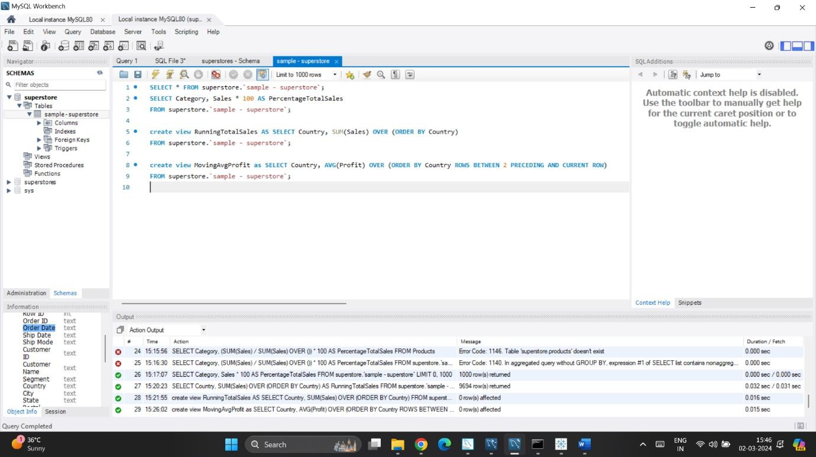

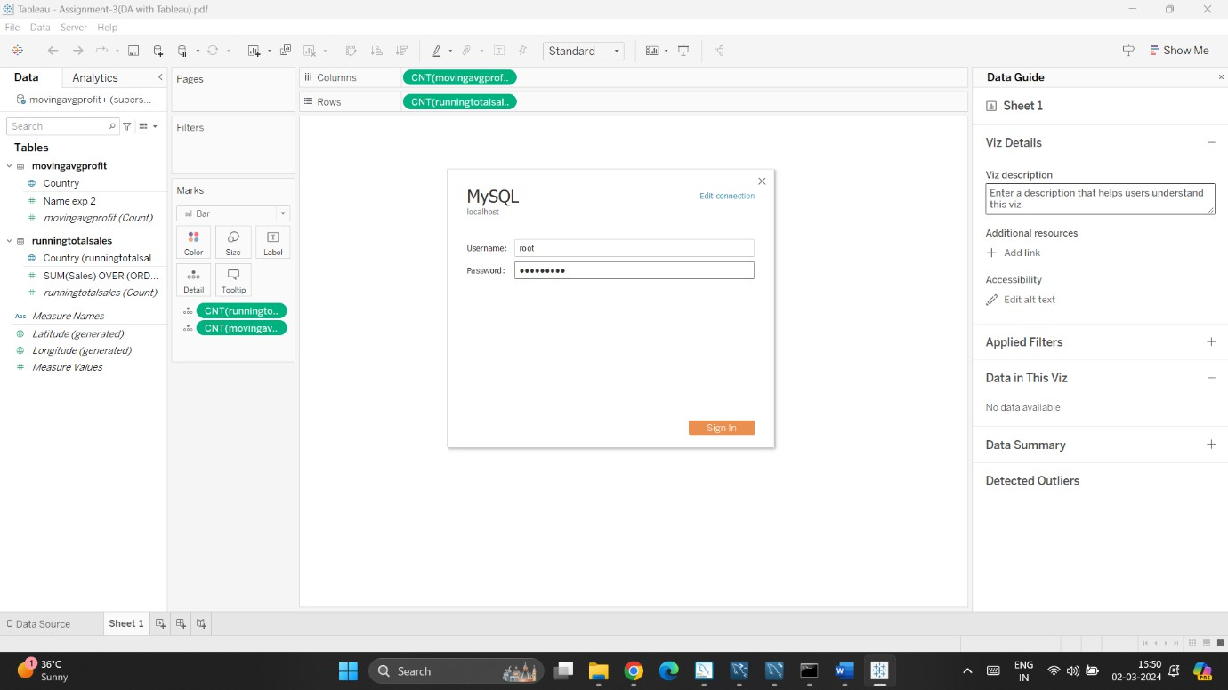

VISUALIZATION OF TEMPERORY SETS:

1. **RUNNINGTOTALSALES**
2. **MOVINGAVGPROFIT**

